Send Disk Space Report - SQL Server

<https://www.ourtechideas.com/blog/disk-space-report/>

# Scenario

Send Disk space report daily by a Job. Here we will use a TSQL script for the activity.

The script will create two temporary tables for the activity and use the Database mail to send the report via email.

# Steps

1) First Configure Database mail in SQL Server if it is not configured before.

You can follow the link for instruction: <https://www.ourtechideas.com/blog/configure-database-mail/>

2) Create a Job for the activity & schedule as per your requirement

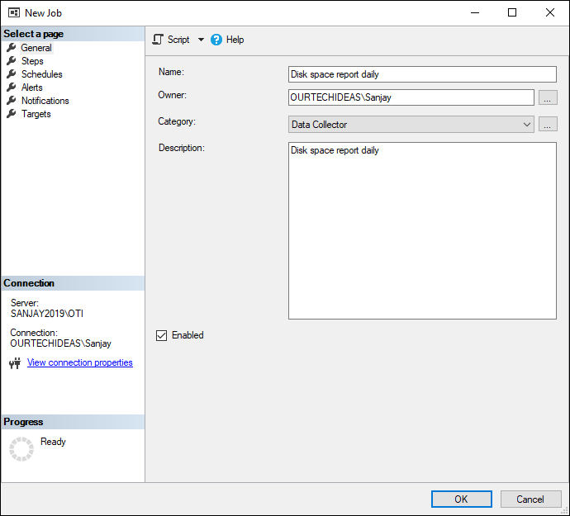

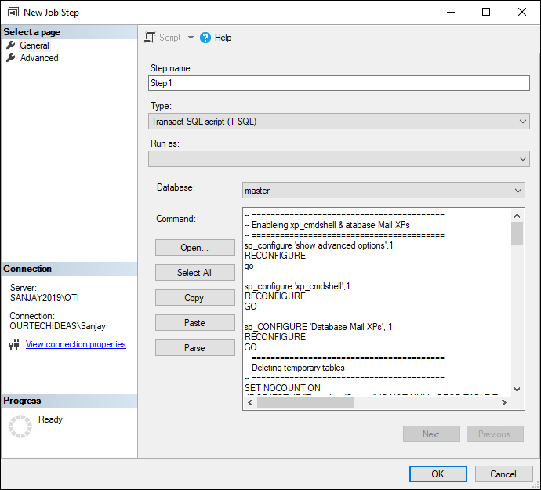

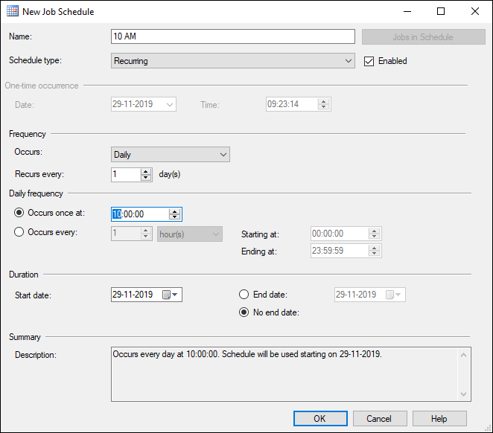

**3) Modify the script & use it in the Job**

* *Must modify in the script*
  + *Email Sender Name*
  + *DB Mail Profile*
  + *Recipients Email*
  + *Copy Recipients Email*

TSQL Script



-- =========================================

-- Enableing xp_cmdshell & atabase Mail XPs

-- =========================================

sp_configure 'show advanced options',1

RECONFIGURE

go

sp_configure 'xp_cmdshell',1

RECONFIGURE

GO

sp_CONFIGURE 'Database Mail XPs', 1

RECONFIGURE

GO

-- =========================================

-- Deleting temporary tables

-- =========================================

SET NOCOUNT ON

IF OBJECT_ID('Tempdb..#Creport') IS NOT NULL DROP TABLE Tempdb..#Creport;

IF OBJECT_ID('Tempdb..#output') IS NOT NULL DROP TABLE Tempdb..#output;

-- ========================================================================================

-- by default it will take the current server name, we can set the server name as well

-- ========================================================================================

DECLARE @sql varchar(4000)

DECLARE @LOCAL_NET_ADDRESS varchar(20)

DECLARE @svrName varchar(20)

set @svrName = CAST (SERVERPROPERTY('ComputerNamePhysicalNetBIOS') as varchar(30))

Set @LOCAL_NET_ADDRESS = Cast (CONNECTIONPROPERTY('LOCAL_NET_ADDRESS') as varchar (255))

set @sql = 'powershell.exe -c "Get-WmiObject -ComputerName ' + QUOTENAME(@svrName,'''') +

' -Class Win32_Volume -Filter ''DriveType = 3'' | select name,capacity,freespace | foreach{$_.name+''|''+$_.capacity/1048576+''%''+$_.freespace/1048576+''*''}"'

-- ===========================

-- creating a temporary table

-- ===========================

CREATE TABLE Tempdb..#output

(line varchar(255))

CREATE TABLE Tempdb..#Creport

(

[SERVER NAME] varchar (100),

DRIVENAME varchar (100),

CAPACITY_GB INT,

FREESPACE_GB INT,

USED_SPACE_PERCENTAGE AS (100-(FREESPACE_GB * 100/ CAPACITY_GB))

)

insert #output

EXEC xp_cmdshell @sql

--script to retrieve the values in MB from PS Script output

--script to retrieve the values in GB from PS Script output

-- ===========================================================================

-- inserting disk name, total space and free space value in to temporary table

-- ===========================================================================

INSERT INTO Tempdb..#Creport

SELECT --CONNECTIONPROPERTY('LOCAL_NET_ADDRESS') AS LOCAL_NET_ADDRESS,

@SVRNAME[SERVER NAME],

RTRIM(LTRIM(SUBSTRING(LINE,1,CHARINDEX('|',LINE) -1))) AS DRIVENAME

,ROUND(CAST(RTRIM(LTRIM(SUBSTRING(LINE,CHARINDEX('|',LINE)+1,(CHARINDEX('%',LINE) -1)-CHARINDEX('|',LINE)) )) AS FLOAT)/1024,0) AS 'CAPACITY(GB)'

,ROUND(CAST(RTRIM(LTRIM(SUBSTRING(LINE,CHARINDEX('%',LINE)+1,(CHARINDEX('*',LINE) -1)-CHARINDEX('%',LINE)) )) AS FLOAT) /1024 ,0)AS 'FREESPACE(GB)'

from Tempdb..#output

where line like '[A-Z][:]%'

order by drivename

-- =================================

-- HTML

-- =================================

DECLARE @tableHTML NVARCHAR(MAX) ;

declare @servername varchar(max)

set @servername=@@SERVERNAME

SET @tableHTML =

N'<H3> Disk space available on: ' + @svrName + '</H3>'+-- ' | ' + @LOCAL_NET_ADDRESS +

N'<table border="1" Cellspacing="0" cellpadding="0" style="font-size:x-small;">' +

N'<tr style="background-color:#FFFF00;color:black;font-weight:bold;" align="center">' +

N'<td align=center><b>SERVER NAME</b></td>

<td align=center><b>DRIVENAME</b></td>

<td align=center><b>CAPACITY(GB)</b></td>

<td align=center><b>FREESPACE(GB)</b></td>

<td align=center><b>USED_SPACE_PERCENTAGE</b></td>'+

CAST ( ( SELECT

td= [SERVER NAME],'',

td= [DRIVENAME],'',

td= [CAPACITY_GB],'',

td= [FREESPACE_GB],'',

td= [USED_SPACE_PERCENTAGE],''

FROM #Creport

FOR XML PATH('tr'), TYPE

) AS NVARCHAR(MAX) )+

N'</center></table>' + N'<BR><BR><BR>Thanks<BR> Sanjay Humania <BR><BR>' ; ; -- Sender's Name

if (select count(*) FROM #Creport) > 0

Begin

DECLARE @today varchar(20) = convert(varchar, getdate(), 105)

DECLARE @subject Nvarchar(max)

DECLARE @sqlstr varchar (400)

set @sqlstr ='Disk space available on: '+ @svrName --+ ' | ' + @LOCAL_NET_ADDRESS --+' | ' + @today

-- ==========================================

-- Email server configuration

-- ==========================================

EXEC msdb.dbo.sp_send_dbmail

@profile_name = 'SQL_DB_Email', -- Change Profile Name

@recipients = 'sanjay.humania@gmail.com;', -- Change recipients name

@copy_recipients = 'sanjayhumania@gmail.com;', -- Change copy recipients name

@subject = @sqlstr,

@body = @tableHTML,

@body_format = 'HTML' ;

End

-- ===================================

-- Deleting temp tables

-- ===================================

Drop table [#Creport]

go

sp_configure 'xp_cmdshell',0

go

RECONFIGURE

-- =======

-- END

-- =======

# Result

